
Pir Meher Ali Shah
Arid Agriculture University, Rawalpindi
Office of the controller of Examinations
Final Exam / SPRING 2021 (Paper Duration 12 hours)
PRACTICAL
Course No.: CS-577 Course Title: Computer Networks
Total Marks: 20 Date of Exam: 5-07-2021
Degree/Semester/Section: BS(IT/CS)-4th/6th (A/B)(Morning/Evening)
Q.No. | 1 | 2 | 3 | 4 | 5 | 6 | 7 | 8 | 9 | 10 | Marks  Obtained/  Total Marks
Marks  Obtained |  |  |  |  |  |  |  |  |  |  | __/20

Total Marks in Words:
Name of the teacher: Dr. Saleem Iqbal/Dr. Kashif Sattar/Dr. Mushhad Gillani/Mr. Azhar Manzoor
Who taught the course: Signature of teacher / Examiner:

To be filled by Student

Registration No.: ………………………………………….……… Name:………………………………………………………………….

Instructions: 1. Write your Name and Registration Number in the space provided above.
2. Save the file name “YY-Arid-YourNo YourName CS577 FinalPrSp21.doc”.
3. Upload file at least 1-2 hr. before deadline. 12 hrs. are for both Theory & Pract.
4. After uploading view your uploaded file that either the file is correct or not?

Question #1 [2+2+2+4+4=14 Marks]
PMAS-Arid Agriculture University has a main campus near shamasabad muree road Rawalpindi. Along with that it has four sub campuses at different locations as shown in figure Q1. Public IP requirement of all campuses is also shown in figure. Each site needs internet connectivity. If the university has 173.16.0.0/22 public addresses then you have to design the subnets and answer the following questions:
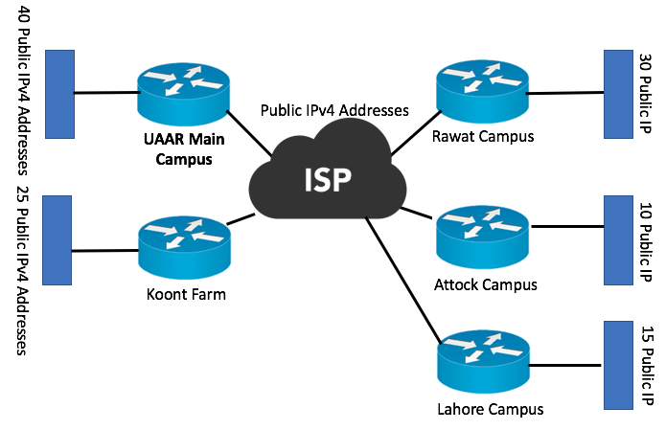

Figure Q1

- How many total subnets are required?
- Based on the maximum hosts how many bits are required from the host portion?
- If equal size subnets are required then how many equal size subnets can be created from the university’s pool of 173.16.0.0/22 public addresses?
- Write down the list of all subnets in format a.b.c.d/n
- Redraw the figure Q1 and Allocate subnets in such a way that 173.16.0.X/26 (where X is your last 2 digit of arid number) should be in main campus.

Question #2 [06 Marks]
With reference to Q1, how you establish subnet of UAAR main campus (only) in packet tracer? (Those who have assigned semester project will write description of their project).

